**SCHOOL OF COMPUTER SCIENCE AND ENGINEERING**

**Fall Semester, 2020-21**

**CSE1007 – Java Programming Lab**

**Digital Assingment-2**

Date: 20/08/2020

19BCE0758

R Narayan

1. Design a class named Rectangle to represent a rectangle. The class contains: Two double data fields named width and height that specify the width and height of the rectangle. The default values are 1 for both width and height.

(i)A default constructor that creates a default rectangle.

(ii)A constructor that creates a rectangle with the specified width and height.

(iii)A method named getArea() that returns the area of this rectangle.

(iv)A method named getPerimeter() that returns the perimeter. Implement the class. Write a test program that creates two Rectangle objects— one with width 5 and height 50 and the other with width 2.5 and height 45.7. Display the width, height, area, and perimeter of each rectangle in this order.

Code:

//*19BCE0758*

//*R Narayan*

import *java*.*util*.*Scanner*;

*public* *class* Rectangle {

*private* double width;

*private* double height;

*public* *Rectangle*() {

        //*Default height = 10 , width = 5*

        this.*width* = 5;

        this.*height* = 50;

    }

*public* *Rectangle*(double w, double h) {

        this.*width* = w;

        this.*height* = h;

    }

*public* double *getArea*() {

*return* width * height;

    }

*public* double *getPerimeter*() {

*return* 2 * width + 2 * height;

    }

*public* *static* void *main*(String[] args) {

        Scanner console = *new* *Scanner*(System.*in*);

        Rectangle rectangle = *new* *Rectangle*();

        System.*out*.*println*("object with default parameters ");

        System.*out*.*println*("Default values " + rectangle.*height* + "  " + rectangle.*width*);

        System.*out*.*println*("Area = " + rectangle.*getArea*());

        System.*out*.*println*("Perimeter = " + rectangle.*getPerimeter*());

        Rectangle rectangle2 = *new* *Rectangle*(2.5, 45.7);

        System.*out*.*println*("object with manually passed  parameters ");

        System.*out*.*println*("Default values " + rectangle2.*height* + "  " + rectangle2.*width*);

        System.*out*.*println*("Area = " + rectangle2.*getArea*());

        System.*out*.*println*("Perimeter = " + rectangle2.*getPerimeter*());

    }

}

Output:

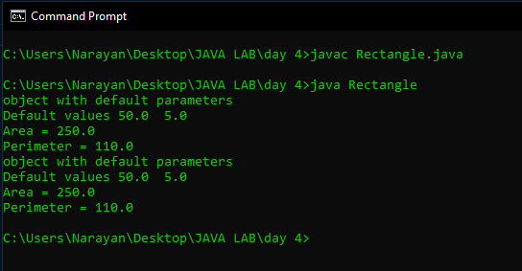

1. Write a Java program to create a class called Student having data members Regno, Name, Course being studied and current CGPA. Include constructor to initialize objects. Create array of objects with at least 10 students and find 9- pointers.

Code:

//*19BCE0758*

//*R Narayan*

import *java*.*util*.*Scanner*;

*public* *class* Cgpa {

*private* String reg;

*private* String name;

*private* String Course;

*private* float cgp;

*public* *Cgpa*( String r,String n, String c, float cg) {

        this.*reg* = r;

        this.*name* = n;

        this.*Course* = c;

        this.*cgp* = cg;

    }

*public* boolean *isNine*() {

*if* (this.*cgp* >= 9)

*return* true;

*else*

*return* false;

    }

*public* void *nameP*() {

        System.*out*.*println*(this.*name*);

    }

*public* *static* void *main*(String[] args) {

        Scanner s = *new* *Scanner*(System.*in*);

        Cgpa[] students = *new* Cgpa[10];

        System.*out*.*println*("Enter the number of students ");

        int n = s.*nextInt*();

*for* (int i = 0; i < n; i++) {

            s.*nextLine*();

            System.*out*.*println*("Enter the Reg No");

            String r = s.*nextLine*();

            System.*out*.*println*("Enter the Name");

            String na = s.*nextLine*();

            System.*out*.*println*("Enter the Course");

            String c = s.*nextLine*();

            System.*out*.*println*("Enter the CGPA");

            float cg = s.*nextFloat*();

            students[i] = *new* *Cgpa*(r, na, c, cg);

        }

        System.*out*.*println*("List of Nine Pointers");

*for* (int i = 0; i < n; i++) {

*if* (students[i].*isNine*()) {

                students[i].*nameP*();

            }

        }

    }

}

Output:

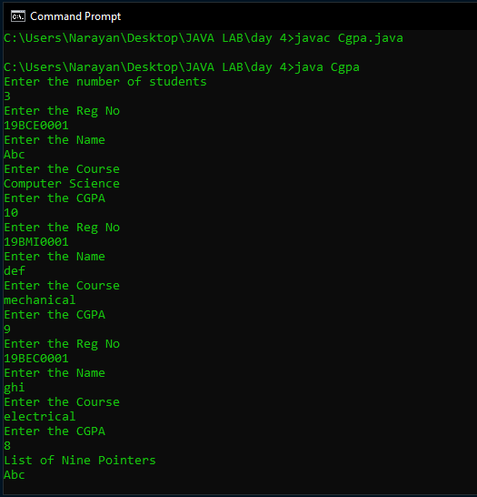

1. Write a Java program that displays that displays the time in different formats in the form of HH,MM,SS using constructor Overloading.

Code:

//*19BCE0758*

//*R Narayan*

import *java*.*util*.*Scanner*;

*public* *class* Time {

*public* void *disp*(String hh) {

        System.*out*.*println*(hh);

    }

*public* void *disp*(String hh, String mm) {

        System.*out*.*println*(hh + ":" + mm);

    }

*public* void *disp*(String hh, String mm, String ss) {

        System.*out*.*println*(hh);

    }

*public* *static* void *main*(String[] args) {

        Scanner s = *new* *Scanner*(System.*in*);

        Time t = *new* *Time*();

        System.*out*.*println*("Function 1");

        t.*disp*("10");

        System.*out*.*println*("Function 2");

        t.*disp*("10", "30");

        System.*out*.*println*("Function 3");

        t.*disp*("10", "30", "55");

    }

}

Output:

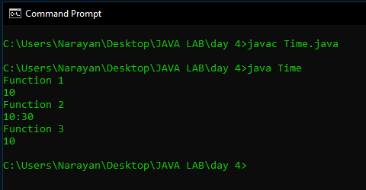

1. Write a Java program that displays area of different Figures (Rectangle, Square, Triangle) using the method overloading.

Code:

//*19BCE0758*

//*R Narayan*

import *java*.*lang*.*Math*;

import *java*.*util*.*Scanner*;

*class* Area {

*public* void *retArea*(int l, int b) {

        System.*out*.*println*("Area of rectangle is " + l * b);

    }

*public* void *retArea*(int s) {

        System.*out*.*println*("Area of square is " + s * s);

    }

*public* void *retArea*(int a, int b, int c) {

*if* (a + b > c && b + c > 5 && c + a > b) {

            float s = (a + b + c) / 2;

            System.*out*.*println*("Area is " + Math.*sqrt*((s * (s - a) * (s - b) * (s - c))));

        } *else* {

            System.*out*.*println*("Sorry the dimensions is not of a triangle");

        }

    }

}

*class* Areas {

*public* *static* void *main*(String args[]) {

        int n = 1;

        Scanner sc = *new* *Scanner*(System.*in*);

        Area ob = *new* *Area*();

*do* {

            System.*out*.*println*("Area of 1.Triangle 2.Rectangle 3.Square 4.exit ?");

            n = sc.*nextInt*();

*if* (n == 1) {

                System.*out*.*println*("Enter the 3 sides of the triangle");

                int a, b, c;

                a = sc.*nextInt*();

                b = sc.*nextInt*();

                c = sc.*nextInt*();

                ob.*retArea*(a, b, c);

            } *else* *if* (n == 2) {

                System.*out*.*println*("Enter the 2 sides of the rectangle");

                int a, b;

                a = sc.*nextInt*();

                b = sc.*nextInt*();

                ob.*retArea*(a, b);

            } *else* *if* (n == 3) {

                System.*out*.*println*("Enter the side of the square");

                int a;

                a = sc.*nextInt*();

                ob.*retArea*(a);

            } *else* *if* (n != 4) {

                System.*out*.*println*("Enter a valid choice");

            }

        } *while* (n != 4);

    }

}

Output:

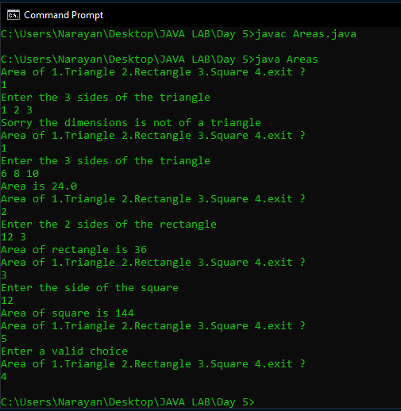

1. In a school, students of all classes from std I to X appear for the MathPremierLeague examination. Define a class MPL which stores the details of the marks scored by each class. It should contain the following 4 data members: Standard, number of students, marks[] array to store the scores of all the students of the class in MPL exam. Define a parameterized constructor which receives the values for the first two data members from the main() method. Create a Form within the constructor, read the marks of all students and hence find the first mark. Define a method findBestClass() to display the standard which has secured the highest mark. Overload this method to display the standard with the highest class average. The marks array should be declared dynamically based on the strength of the class.

Code:

//*19BCE0758*

//*R NARAYAN*

import *java*.*util*.*Scanner*;

*class* MPL {

    int nStudents;

    int[] marks = *new* int[10];

    int std;

    int max = -1;

*MPL*(int s, int ns) {

        this.*std* = s;

        this.*nStudents* = ns;

        Scanner sc = *new* *Scanner*(System.*in*);

        System.*out*.*println*("Enter marks for " + ns + " std Students");

*for* (int i = 0; i < ns; i++) {

            this.*marks*[i] = sc.*nextInt*();

*if* (this.*marks*[i] > max) {

                max = marks[i];

            }

        }

    }

    float *getAvg*() {

        int s = 0;

*for* (int i = 0; i < this.*nStudents*; i++) {

            s += this.*marks*[i];

        }

*return* s / this.*nStudents*;

    }

}

*public* *class* MplTest {

*public* *static* void *main*(String args[]) {

        MPL[] m = *new* MPL[4];

        m[0] = *new* *MPL*(5, 6);

        m[1] = *new* *MPL*(10, 5);

        m[2] = *new* *MPL*(8, 4);

        m[3] = *new* *MPL*(7, 7);

*bestClass*(m);

*bestClass*(m, 1);

    }

*static* void *bestClass*(MPL[] m) {

        int max = 0;

*for* (int i = 0; i < 4; i++) {

*if* (m[i].*max* > m[max].*max*) {

                max = i;

            }

        }

        System.*out*.*println*("Best class = " + m[max].*std* + " Marks: " + m[max].*max*);

    }

*static* void *bestClass*(MPL[] m, int a) {

        int max = 0;

*for* (int i = 0; i < 4; i++) {

*if* (m[i].*getAvg*() > m[max].*getAvg*()) {

                max = i;

            }

        }

        System.*out*.*println*("Best class avg = " + m[max].*std* + " Marks: " + m[max].*getAvg*());

    }

}

Output:

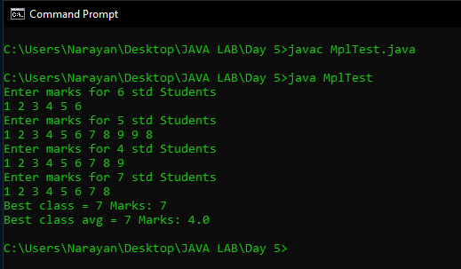

1. Read the following details of ‘n’ students using Scanner class methods and display the same. - Registration number ( String)

- Name (String that may contain first name, middle name and last name)

- CGPA (Floating point number)

- Programme Name(String)

- School Name (String with multiple words)

- Proctor Name (String that may contain first, middle and last names)

Code:

//*19BCE0758*

//*R NARAYAN*

import *java*.*util*.*\**;

*public* *class* Students {

*public* *static* void *main*(String args[]) {

        Scanner sc = *new* *Scanner*(System.*in*);

        String reg = *new* *String*();

        String name = *new* *String*();

        float cgpa;

        String pname = *new* *String*();

        String Sname = *new* *String*();

        String Proctorname = *new* *String*();

        System.*out*.*println*("Enter the details");

        System.*out*.*println*("Enter the Reg no");

        reg = sc.*next*();

        sc.*nextLine*();

        System.*out*.*println*("Enter the Name ");

        name = sc.*next*();

        sc.*nextLine*();

        System.*out*.*println*("Enter the cgpa ");

        cgpa = sc.*nextFloat*();

        System.*out*.*println*("Enter the programme name ");

        pname = sc.*next*();

        sc.*nextLine*();

        System.*out*.*println*("Enter the school");

        Sname = sc.*next*();

        sc.*nextLine*();

        System.*out*.*println*("Enter the proctors name");

        Proctorname = sc.*next*();

        sc.*nextLine*();

        System.*out*.*println*("Student name : " + name + "\nRegNo : " + reg + "\nCGPA : " + cgpa + "\nprogramme name : "

                + pname + "\nSchool name : " + Sname + "\nProctor name : " + Proctorname);

    }

}

Output:

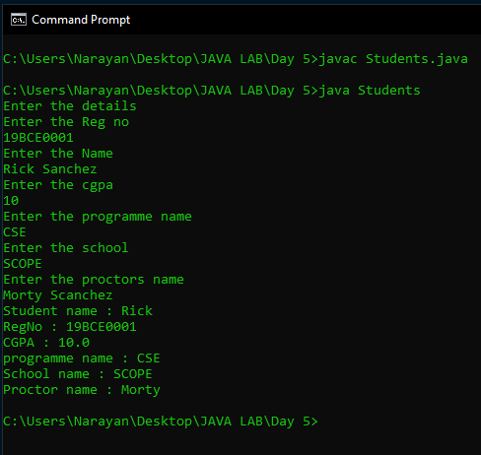

1. A training centre conducts a total of 7 tests for its students. Students are allowed to skip few tests. Let there be 25 students in the batch. So in the main class for every student, read the number of tests taken and the marks scored in each test. A class ‘TestDetails’ should be defined with a 2D array of float type to store the marks of all the students. Define a method ‘storeMarks()’ that will receive the following details for every student from the main class and create in the 2D array, those many columns equal to the number of tests, so as to store the marks. There is no need to store the number of tests. Define another method ‘displayMarks()’ to print the details. Also the training centre wishes to keep those students in notice period who have taken < 3 tests and those who have not scored ≥ 50 in at least 3 tests. Derive another class ‘NoticePeriod’ from ‘TestDetails’ that includes a method to count and print the number of students in bench. Also it should print the ID of those students assuming the row index of the array to be their ID. While checking do not proceed to check the marks in all tests, if the student has already scored more than 50 in 3 tests. Instantiate this class from the main class and do the required processing.

Code:

//*19BCE0758*

//*R NARAYAN*

import *java*.*util*.*Random*;

*class* TestDetails {

*final* int m = 25;

*final* int n = 7;

*public* float[][] marks = *new* float[m][n];

*public* void *storeMarks*() {

        Random rand = *new* *Random*();

*for* (int i = 0; i < m; i++) {

*for* (int j = 0; j < n; j++) {

                boolean isTest = (rand.*nextInt*(2) == 1) *?* true *:* false;

*if* (isTest) {

                    marks[i][j] = rand.*nextInt*(101);

                } *else*

                    marks[i][j] = -1;

            }

        }

    }

*public* void *displayMarks*() {

*for* (int i = 0; i < m; i++) {

            System.*out*.*print*(" Student " + i + ":  ");

*for* (int j = 0; j < n; j++) {

*if* (marks[i][j] != -1) {

                    System.*out*.*print*(marks[i][j] + " ");

                }

            }

            System.*out*.*println*();

        }

    }

}

*class* NoticePeriod *extends* TestDetails {

    boolean[] notice = *new* boolean[m];

    void *calcNotics*() {

        int studentCount = 0;

*for* (int i = 0; i < m; i++) {

            int testCount = 0;

            int marksCount = 0;

*for* (int j = 0; j < n && marksCount < 3; j++) {

*if* (marks[i][j] != -1) {

                    testCount++;

                }

*if* (marks[i][j] >= 50) {

                    marksCount++;

                }

            }

*if* (testCount < 3 || marksCount < 3) {

                notice[i] = true;

                studentCount++;

            } *else* {

                notice[i] = false;

            }

        }

        System.*out*.*println*("Number of students benched = " + studentCount);

    }

    void *displayNotice*() {

*for* (int i = 0; i < m; i++) {

*if* (notice[i]) {

                System.*out*.*println*("Student " + i + " Served with notice");

            }

        }

    }

}

*public* *class* Inheritance1 {

*public* *static* void *main*(String args[]) {

        NoticePeriod n = *new* *NoticePeriod*();

        n.*storeMarks*();

        n.*displayMarks*();

        n.*calcNotics*();

        n.*displayNotice*();

    }

}

Output:

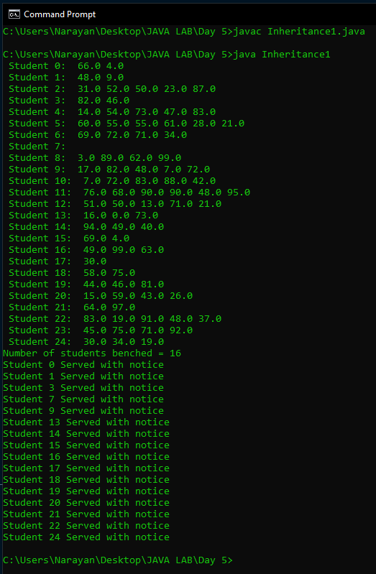

1. Create an inheritance hierarchy in java using following information given below that a bank might use to represent customers’ bank accounts. Base class Account should include one data member of type double to represent account balance. The class should provide constructor that receives an initial balance and uses it to initialize the data member.The constructor should validate the initial balance to ensure that it is greater than or equal to 0.If not the balance is set to 0.0 and the constructor should display an error message,indicating that the initial balance was invalid. The class also provides three member functions credit, debit(debit amount should not exceed the account balance) and enquiry.Derived class SavingsAccount should inherit the functionality of an Account, but also include data member of type double indicating the interest rate assigned to the Account. SavingsAccount constructor should receive the initial balance, as well as an initial value for SavingsAccount’s interest rate. SavingsAccount should provide public member function calculateInterest that returns double indicating the amount of interest earned by an account.The method calculateInterest should determine this amount by multiplying the interest rate by the account balance.SavingsAccount function should inherit member functions credit,debit and enquiry without redefining them. Derived class CheckingAccount should inherit the functionality of an Account, but also include data member of type double that represents the fee charged per transaction. CheckingAccount constructor should receive the initial balance, as well as parameter indicating fee amount. class CheckingAccount should redefine credit and debit function so that they subtract the fee from account balance whenever either transaction is performed. CheckingAccount’s debit function should charge a fee only if the money is actually withdrawn (debit amount should not exceed the account balance).After defining the class hierarchy, write program that creates object of each class and tests their member functions. Add interest to SavingAccount object by first invoking its calculateInterest function, then passing the returned interest amount to object’s credit function.

Code:

//*19BCE0758*

//*R NARAYAN*

import *java*.*util*.*Scanner*;

*class* Account {

    double balance;

*Account*(double balance) {

*if* (balance > 0) {

            this.*balance* = balance;

        } *else* {

            System.*out*.*println*("Invalid");

        }

    }

    void *credit*(double money) {

        this.*balance* += money;

        System.*out*.*println*("Success! New balance is " + this.*balance*);

    }

    void *debit*(double money) {

*if* (money <= this.*balance*) {

            this.*balance* -= money;

            System.*out*.*println*("Success! New balance is " + this.*balance*);

        } *else* {

            System.*out*.*println*("Insufficient Funds");

        }

    }

}

*class* SavingsAccount *extends* Account {

    double intrestRate;

*SavingsAccount*(double balance, double intrestRate) {

        super(balance);

        this.*intrestRate* = intrestRate;

    }

*public* double *calculateIntrest*() {

        System.*out*.*println*("Success intrest rate is " + this.*intrestRate*);

*return* this.*intrestRate* * this.*balance*;

    }

}

*class* checkingAccount *extends* Account {

    double transactionFee;

*checkingAccount*(double bal, double tf) {

        super(bal);

        this.*transactionFee* = tf;

    }

    void *credit*(double money) {

        this.*balance* += money;

        this.*balance* -= this.*transactionFee*;

        System.*out*.*println*("Success! New balance is " + this.*balance*);

    }

    void *debit*(double money) {

*if* (money <= this.*balance* + this.*transactionFee*) {

            this.*balance* -= money;

            this.*balance* -= this.*transactionFee*;

            System.*out*.*println*("Success! New balance is " + this.*balance*);

        } *else* {

            System.*out*.*println*("Insufficient Funds");

        }

    }

}

*public* *class* Inheritance2 {

*public* *static* void *main*(String args[]) {

        SavingsAccount savings = *new* *SavingsAccount*(200, 5);

        savings.*credit*(savings.*calculateIntrest*());

        savings.*debit*(25);

        checkingAccount check = new checkingAccount(200, 5);

        check.*credit*(100);

        check.*debit*(25);

    }

}

Output:

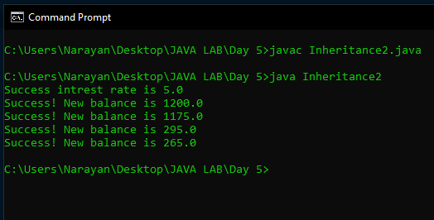

1. Write an interface called Exam with a method Pass ( ) that returns the total marks. Write another interface called Classify with a method Average (int total) which returns a string. Write a Class called Result which implements both Exam and Classify. The Pass method should get the marks from the user and finds the total marks and return. The Division method calculate the average marks and return “First” if the average is 60 or more, “SECOND” when average is 50 or more but below 60, “NO DIVISION” when average is less than 50

Code:

//*19BCE0758*

//*R NARAYAN*

import *java*.*util*.*Scanner*;

*interface* Exam {

    int *Pass*();

}

*interface* Classify {

    String *Average*(int total);

}

*public* *class* result *implements* Exam, Classify {

    Scanner sc = *new* *Scanner*(System.*in*);

*public* int n;

*static* int tot = 0;

*public* int *Pass*() {

        System.*out*.*println*("Enter the number of subjects:");

        n = sc.*nextInt*();

        System.*out*.*println*("Enter the marks:");

*for* (int i = 0; i < n; i++) {

            tot += sc.*nextInt*();

        }

*return* tot;

    }

*public* String *Average*(int total) {

        int avg = total / n;

*if* (avg > 60)

*return* "FIRST";

*else* *if* (avg > 50 & avg < 60)

*return* "SECOND";

*else*

*return* "NO DIVISION";

    }

*public* *static* void *main*(String[] args) {

        result res = *new* *result*();

        res.*Pass*();

        System.*out*.*println*(res.*Average*(tot));

    }

}

Output:

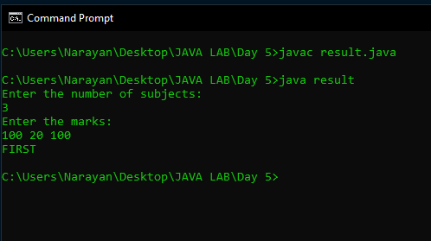

1. Write an abstract class special with an abstract method double Process (double P,double R). Create a subclass Discount and implement the Process() method with the following formula: net=P-P*R/100. Return the Process() method with the following formula: total=P+P*R/100. Return the total.

Code:

//*19BCE0758*

//*R NARAYAN*

import *java*.*util*.*Scanner*;

*abstract* *class* Net {

    double p;

    double r;

*abstract* void *Process*(double P, double R);

}

*class* Discount *extends* Net {

*public* void *Process*(double x, double y) {

        p = x;

        r = y;

    }

*public* double *getdata*() {

        double net = p - p * r / 100;

*return* net;

    }

}

*class* Tax *extends* Discount {

*public* double *getdata*() {

        double total = p + p * r / 100;

*return* total;

    }

}

*public* *class* Abstract {

*public* *static* void *main*(String[] args) {

        Discount o1 = *new* *Discount*();

        Tax o2 = *new* *Tax*();

        o1.*Process*(4, 8);

        o2.*Process*(4, 8);

        System.*out*.*println*("Net=" + o1.*getdata*());

        System.*out*.*println*("Total=" + o2.*getdata*());

    }

}

Output:

